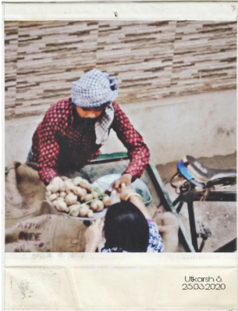

Peak afternoon.Shining sun.Silent streets.Temperature much warmer than what you'd expect of March.

Suddenly, the voice of this vendor, which earlier would just be recognised as a part of the daily commotion, tears through the silence.

Soon, my neighbour, from his balcony, asks him about potato rates. "Rs.30/kg"

"Wouldn't you cut it down a little?"

"No chance sir"

"I might just take it!"

"Not possible sir, and it doesn't matter if you take it or not. Even the wholesalers are selling it at Rs. 25, and I had to face abuses, you know how they are, along with 2 laathi strokes from the police to provide you this service, and today is the last. I'll be staying home starting tomorrow.
Earning only matters if I live to spend it, and contracting this disease will only mean more expenses for me."

Another man, from his balcony, asks if he had any onion, to which the vendor replied he had none. Onion, priced at rs.60/ kg, were very expensive for him to buy in bulk, for he himself didn't know if anyone would buy them. So he just took 20 kgs, of them for the day. It wasn't much time before a man came, and bought 10 kgs of onion at once. And soon, his stock of onions was completely sold out.

"How could have I known that such was the condition, I doubted if I'd sell anything today,but the fear of hunger seems more haunting to people than the fear of contracting the disease "

A woman came, bought 10 kgs of potatoes, and his stock for the day was over.

